# 任务单 创建对话框

## 演示任务

**1、项目准备**

**设计主界面，顶部为文本显示框，用于显示操作结果；界面中心包含4个按钮，用于打开4种不同类型的对话框。**

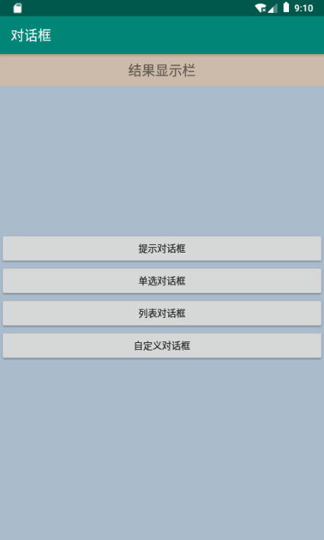

**2、提示对话框**

**创建对话框，包含标题、图标、显示信息及“确定”、“取消”两个按钮。**

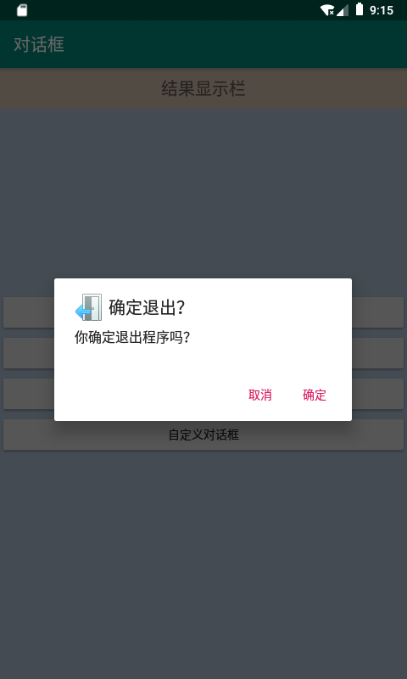 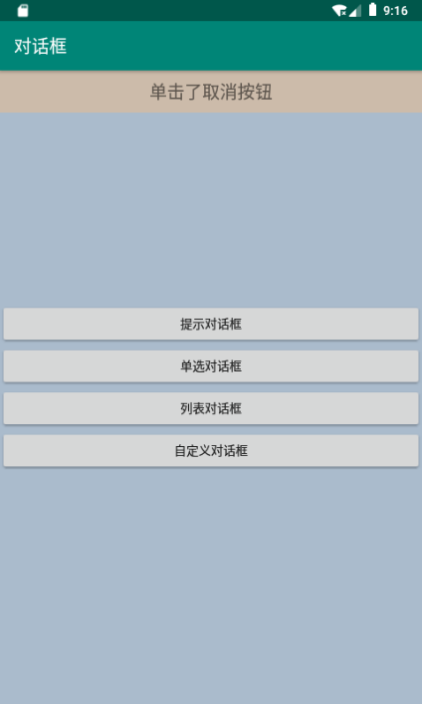

**3、单选对话框**

带**单选按钮**的对话框，可以设置结果显示栏内字体的颜色。

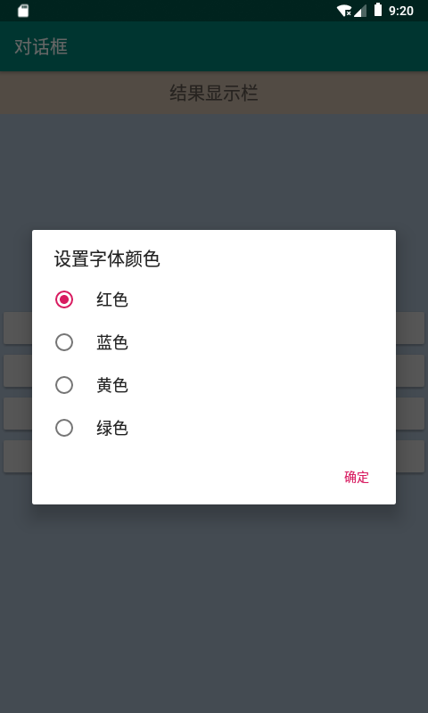 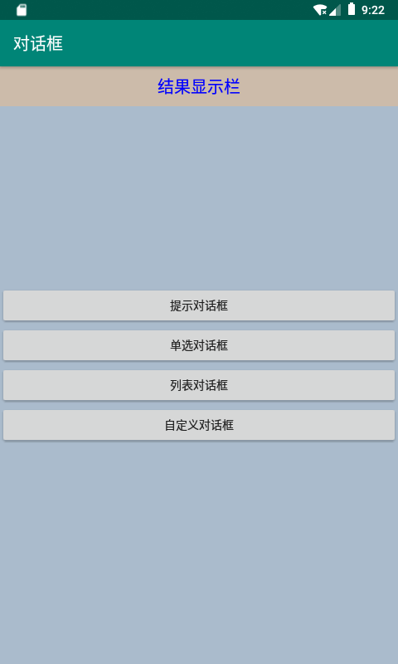

**练习任务【选做】**

**模仿qq的状态选择，首先弹出选择对话框，可从提供的状态中选择一个；但是若选择“其他”则弹出输入对话框，以用户输入的文本作为自定义状态。如下图所示。（提示：对话框的setView()方法可以向对话框内添加控件）**

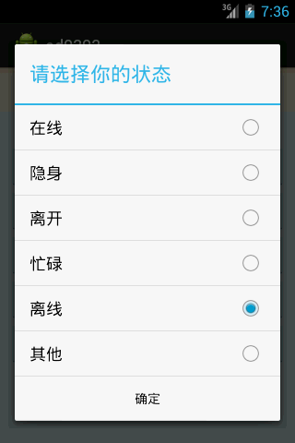 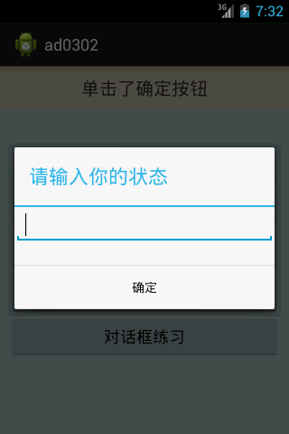

**=======提交规范=======**

**提交word文档，对应在每个任务下面添加程序代码，以姓名作为文件名。**

**截图：**

**演示任务：**

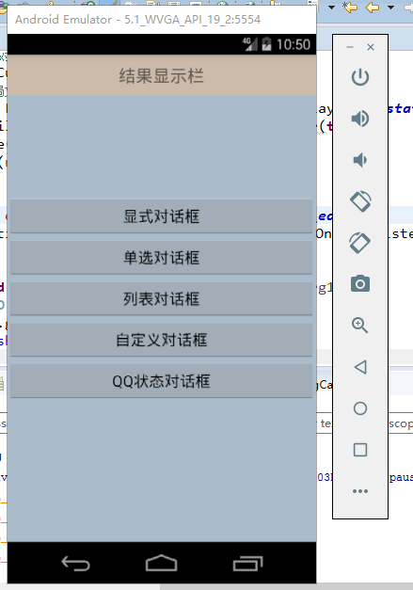

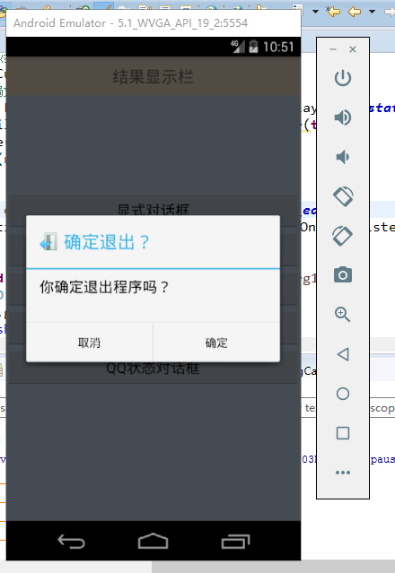

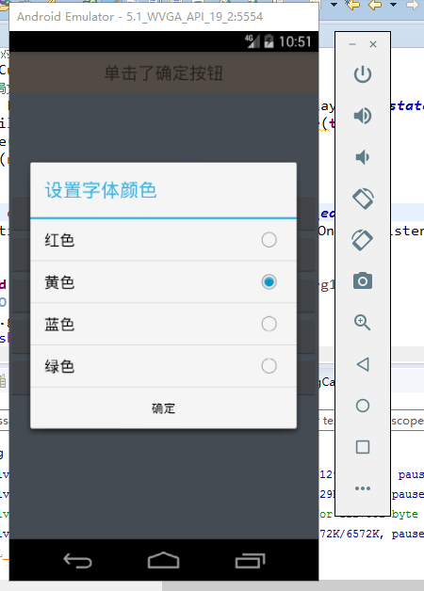

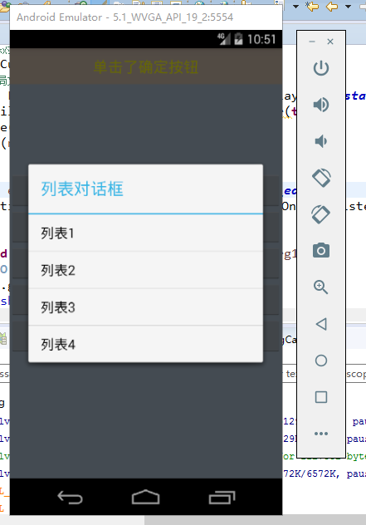

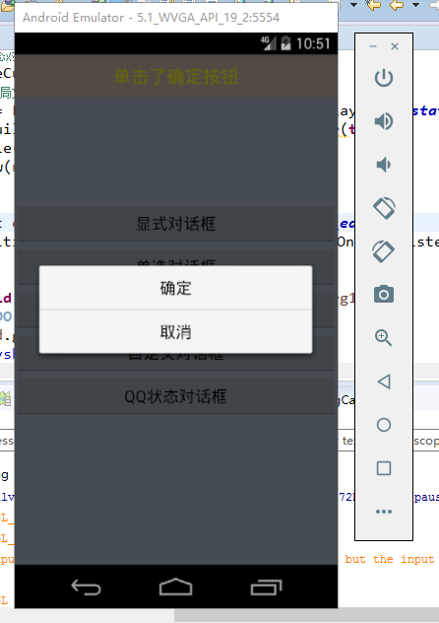

**练习任务：**

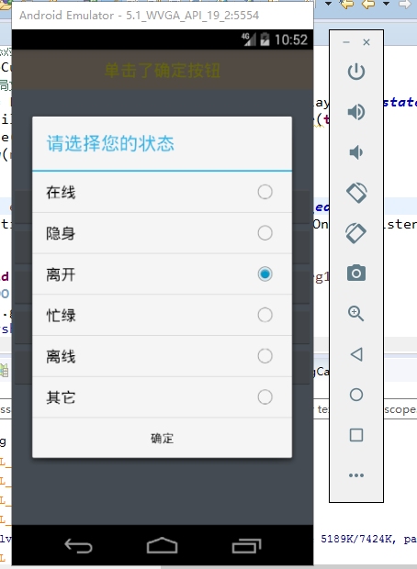

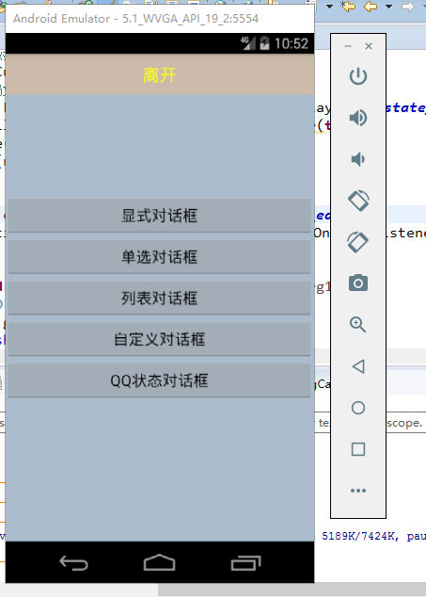

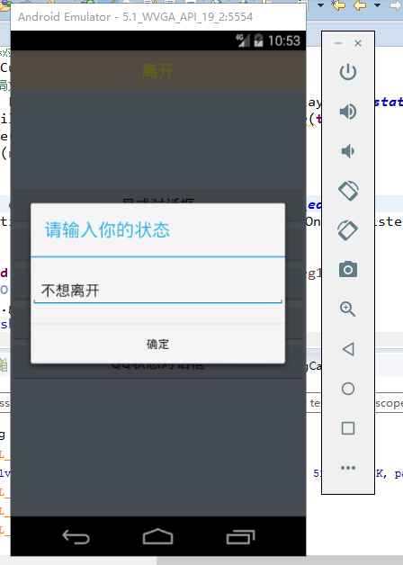

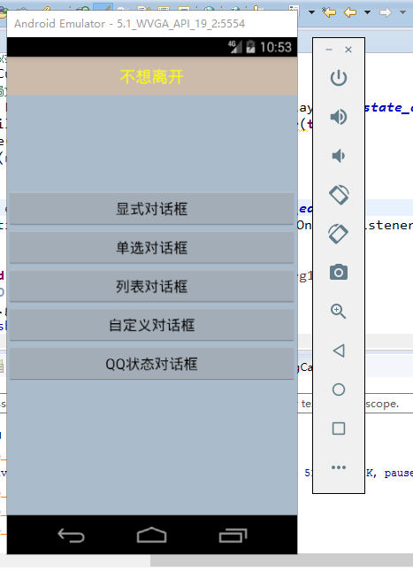

**代码：**

**Java代码 演示任务和练习任务合在一起**

**Mainactivity.java**

**package** com.example.t52;

**import** android.app.Activity;

**import** android.app.AlertDialog;

**import** android.app.Dialog;

**import** android.content.DialogInterface;

**import** android.graphics.Color;

**import** android.os.Bundle;

**import** android.text.AlteredCharSequence;

**import** android.view.LayoutInflater;

**import** android.view.Menu;

**import** android.view.MenuItem;

**import** android.view.View;

**import** android.view.Window;

**import** android.view.View.OnClickListener;

**import** android.widget.Button;

**import** android.widget.EditText;

**import** android.widget.TextView;

**import** android.widget.Toast;

**public** **class** MainActivity **extends** Activity **implements** OnClickListener{

TextView tvshow;

Button bt1, bt2, bt3, bt4, bt5;

@Override

**protected** **void** onCreate(Bundle savedInstanceState) {

**super**.onCreate(savedInstanceState);

setContentView(R.layout.***activity_main***);

findTag();

}

**void** findTag(){

tvshow = findViewById(R.id.***tv_show***);

bt1 = findViewById(R.id.***btn1***);

bt2 = findViewById(R.id.***btn2***);

bt3 = findViewById(R.id.***btn3***);

bt4 = findViewById(R.id.***btn4***);

bt5 = findViewById(R.id.***btn5***);

bt1.setOnClickListener(**this**);

bt2.setOnClickListener(**this**);

bt3.setOnClickListener(**this**);

bt4.setOnClickListener(**this**);

bt5.setOnClickListener(**this**);

}

@Override

**public** **void** onClick(View v) {

// **TODO** Auto-generated method stub

**switch** (v.getId()) {

**case** R.id.***btn1***:

createconfirmDialog();

**break**;

**case** R.id.***btn2***:

createSingleChoiceDialog();

**break**;

**case** R.id.***btn3***:

createItemsDialog();

**break**;

**case** R.id.***btn4***:

createCustomsDialog();

**break**;

**case** R.id.***btn5***:

creatStateDialog();

**break**;

**default**:

**break**;

}

}

// 创建对话框

**public** **void** createconfirmDialog(){

AlertDialog.Builder di = **new** AlertDialog.Builder(**this**);

di.setTitle("确定退出？");

di.setIcon(R.drawable.***exit***);

di.setMessage("你确定退出程序吗？");

di.setPositiveButton("确定", **new** DialogInterface.OnClickListener() {

@Override

**public** **void** onClick(DialogInterface arg0, **int** arg1) {

// **TODO** Auto-generated method stub

tvshow.setText("单击了确定按钮");

}

});

di.setNegativeButton("取消", **new** DialogInterface.OnClickListener() {

@Override

**public** **void** onClick(DialogInterface arg0, **int** arg1) {

// **TODO** Auto-generated method stub

tvshow.setText("单击了取消按钮");

}

});

di.create().show();

}

**int** idex;

**int** Colorarr[] = {Color.***RED***, Color.***YELLOW***, Color.***BLUE***, Color.***GREEN***};

// 单选对话框

**public** **void** createSingleChoiceDialog(){

String stitems[] = {"红色","黄色","蓝色","绿色"};

AlertDialog.Builder dis = **new** AlertDialog.Builder(**this**);

dis.setTitle("设置字体颜色");

dis.setSingleChoiceItems(stitems, idex, **new** DialogInterface.OnClickListener() {

@Override

**public** **void** onClick(DialogInterface arg0, **int** which) {

// **TODO** Auto-generated method stub

idex = which;

}

});

dis.setPositiveButton("确定", **new** DialogInterface.OnClickListener() {

@Override

**public** **void** onClick(DialogInterface arg0, **int** arg1) {

// **TODO** Auto-generated method stub

tvshow.setTextColor(Colorarr[idex]);

}

});

dis.create().show();

}

// 列表对话框

**public** **void** createItemsDialog(){

String stitems[] = {"列表1","列表2","列表3","列表4"};

AlertDialog.Builder dis = **new** AlertDialog.Builder(**this**);

dis.setTitle("列表对话框");

dis.setItems(stitems, **new** DialogInterface.OnClickListener(){

@Override

**public** **void** onClick(DialogInterface arg0, **int** arg1) {

// **TODO** Auto-generated method stub

Toast.*makeText*(MainActivity.**this**, "选择列表", 300).show();;

}

});

dis.show();

}

// 自定义对话框

**public** **void** createCustomsDialog(){

**final** Dialog dis = **new** Dialog(**this**);

dis.requestWindowFeature(Window.***FEATURE_NO_TITLE***);

dis.setContentView(R.layout.***confirm_dialog***);

Button cfbt = dis.findViewById(R.id.***confirmbt***);

Button cabt = dis.findViewById(R.id.***cancelbt***);

cfbt.setOnClickListener(**new** OnClickListener() {

@Override

**public** **void** onClick(View arg0) {

// **TODO** Auto-generated method stub

dis.dismiss();

}

});

cabt.setOnClickListener(**new** OnClickListener() {

@Override

**public** **void** onClick(View arg0) {

// **TODO** Auto-generated method stub

dis.dismiss();

}

});

dis.show();

}

/* 练习QQ状态代码开始 */

// 加载自定义输入的QQ状态对话框

**public** **void** createCustomState(){

// 先加载自定义的布局文件

View newview = LayoutInflater.*from*(**this**).inflate(R.layout.***instate_dialog***, **null**, **false**);

AlertDialog.Builder dialog = **new** AlertDialog.Builder(**this**);

dialog.setTitle("请输入你的状态");

dialog.setView(newview);

// 设置监听的东西

**final** EditText ed = newview.findViewById(R.id.***state_edit***);

dialog.setPositiveButton("确定", **new** DialogInterface.OnClickListener() {

@Override

**public** **void** onClick(DialogInterface arg0, **int** arg1) {

// **TODO** Auto-generated method stub

**if**(!ed.getText().toString().equals("")){

tvshow.setText(ed.getText().toString());

}

}

});

dialog.create().show();

}

AlertDialog dia = **null**;

**int** stateidex;

String stitems[] = {"在线","隐身","离开","忙绿","离线","其它"};

// 状态选择框

**public** **void** creatStateDialog(){

// 先给予单选项

**final** AlertDialog.Builder dis = **new** AlertDialog.Builder(**this**);

dis.setTitle("请选择您的状态");

dis.setSingleChoiceItems(stitems, stateidex, **new** DialogInterface.OnClickListener() {

@Override

**public** **void** onClick(DialogInterface arg0, **int** which) {

// **TODO** Auto-generated method stub

**if**(which != stitems.length - 1){

stateidex = which;

}**else**{

// 关闭 当前对话框

dia.dismiss();

// 出现新对话框

createCustomState();

}

}

});

dis.setPositiveButton("确定", **new** DialogInterface.OnClickListener() {

@Override

**public** **void** onClick(DialogInterface arg0, **int** arg1) {

// **TODO** Auto-generated method stub

tvshow.setText(stitems[stateidex]);

}

});

dia = dis.create();

dia.show();

}

/* 练习QQ状态代码结束 */

}

Activity_main.xml

<FrameLayout xmlns:android=*"http://schemas.android.com/apk/res/android"*

xmlns:tools=*"http://schemas.android.com/tools"*

android:layout_width=*"match_parent"*

android:layout_height=*"match_parent"*

android:background=*"#aabbcc"*

tools:context=*"${relativePackage}.${activityClass}"* >

<TextView

android:id=*"@+id/tv_show"*

android:layout_width=*"match_parent"*

android:layout_height=*"wrap_content"*

android:background=*"#ccbbaa"*

android:gravity=*"center"*

android:text=*"结果显示栏"*

android:textSize=*"20sp"*

android:padding=*"10dp"* />

<LinearLayout

android:layout_width=*"match_parent"*

android:layout_height=*"wrap_content"*

android:orientation=*"vertical"*

android:layout_gravity=*"center"*

>

<Button

android:id=*"@+id/btn1"*

android:layout_width=*"match_parent"*

android:layout_height=*"wrap_content"*

android:text=*"显式对话框"*

/>

<Button

android:id=*"@+id/btn2"*

android:layout_width=*"match_parent"*

android:layout_height=*"wrap_content"*

android:text=*"单选对话框"*

/>

<Button

android:id=*"@+id/btn3"*

android:layout_width=*"match_parent"*

android:layout_height=*"wrap_content"*

android:text=*"列表对话框"*

/>

<Button

android:id=*"@+id/btn4"*

android:layout_width=*"match_parent"*

android:layout_height=*"wrap_content"*

android:text=*"自定义对话框"*

/>

<Button

android:id=*"@+id/btn5"*

android:layout_width=*"match_parent"*

android:layout_height=*"wrap_content"*

android:text=*"QQ状态对话框"*

/>

</LinearLayout>

</FrameLayout>

confirm_dialog.xml

<LinearLayout xmlns:android=*"http://schemas.android.com/apk/res/android"*

xmlns:tools=*"http://schemas.android.com/tools"*

android:layout_width=*"match_parent"*

android:layout_height=*"match_parent"*

android:orientation=*"vertical"*

tools:context=*"${relativePackage}.${activityClass}"* >

<Button

android:id=*"@+id/confirmbt"*

android:layout_width=*"match_parent"*

android:layout_height=*"wrap_content"*

android:text=*"确定"*

android:background=*"@android:color/transparent"*

/>

<View

android:layout_width=*"match_parent"*

android:layout_height=*"1dp"*

android:background=*"#cccccc"*/>

<Button

android:id=*"@+id/cancelbt"*

android:layout_width=*"match_parent"*

android:layout_height=*"wrap_content"*

android:text=*"取消"*

android:background=*"@android:color/transparent"*

/>

</LinearLayout>

instate_dialog.xml

<LinearLayout xmlns:android=*"http://schemas.android.com/apk/res/android"*

xmlns:tools=*"http://schemas.android.com/tools"*

android:layout_width=*"match_parent"*

android:layout_height=*"match_parent"*

android:orientation=*"vertical"*

tools:context=*"${relativePackage}.${activityClass}"* >

<LinearLayout

android:layout_width=*"match_parent"*

android:layout_height=*"80dp"*

android:gravity=*"center"*>

<EditText

android:id=*"@+id/state_edit"*

android:layout_width=*"match_parent"*

android:layout_height=*"wrap_content"*

android:hint=*"请输入自定义状态"*

/>

</LinearLayout>

</LinearLayout>